**MongoDB Project - Screenshots**

**Name:** Mekapothula Durga Venkateswara Reddy

**Reg.no:** 22BCB7296

**Gamil:** venkateswara.22bcb7296@vitapstudent.ac.in

**Project Title:** Full-Stack Student & Course Management System

**Description:**

The current project is a full-stack web application that allows educational institutions to manage students and course data efficiently. It's built on HTML, CSS, JavaScript (in the front-end), Node.js (in the back end) and MongoDB (for the database). In addition to all CRUD (Create, Read, Update, Delete) operations on students and courses performed by the admin, for it is a full-stack web application, it also has easy navigation, a responsive user interface, as well as an enrolment tracking and status tracking feature, dynamic search for students and courses, among many other functions. It increases efficiency for academic record keeping allowing one central place for school, college or training canter to glean information in real time, all the time on its students and courses.

1.Initial view of web page.

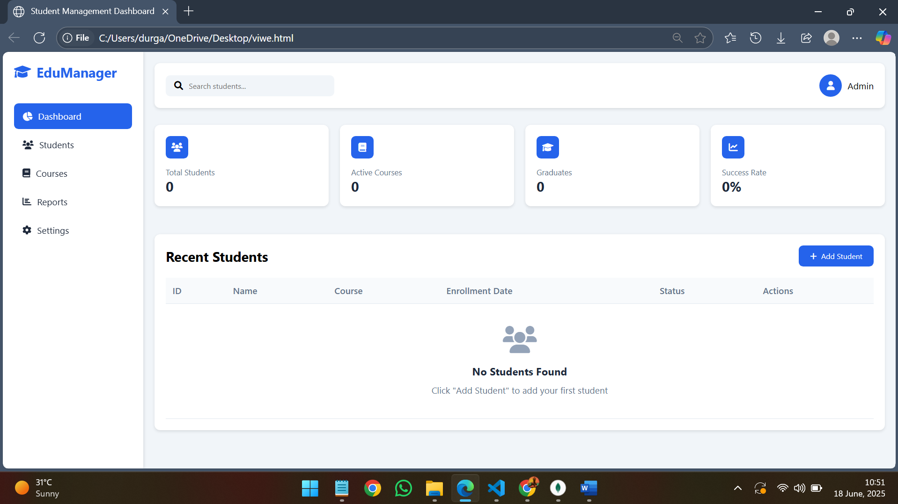

2.Web page notifying to add the course before adding the students.

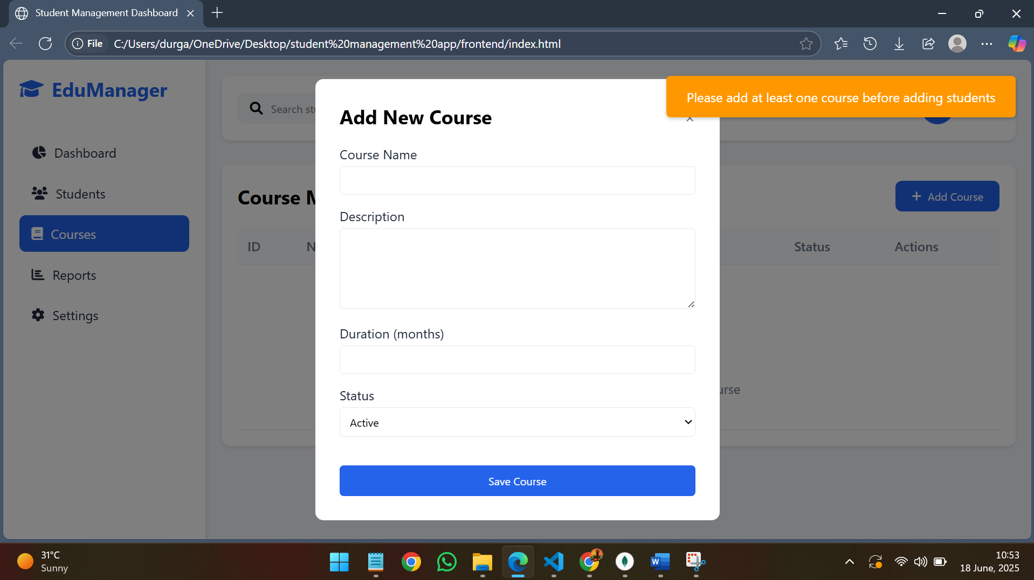

3.Adding the course details.

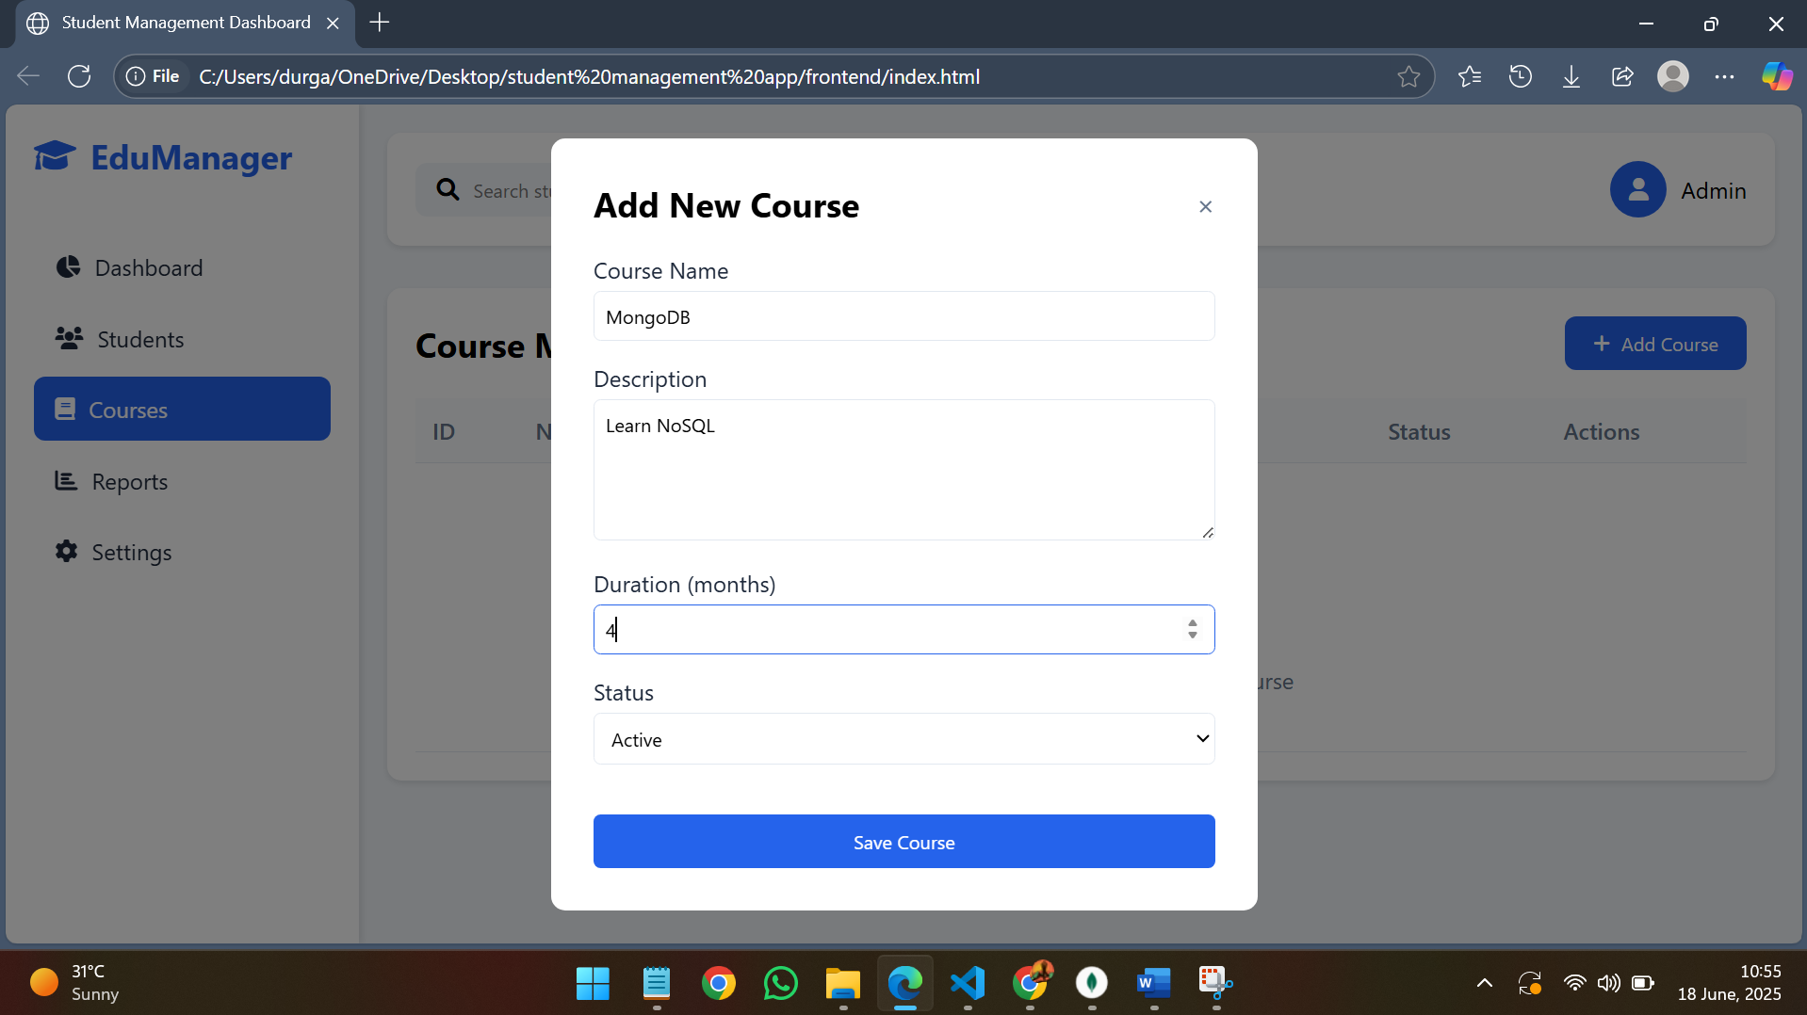

4.Web page notifying that course is added successfully.

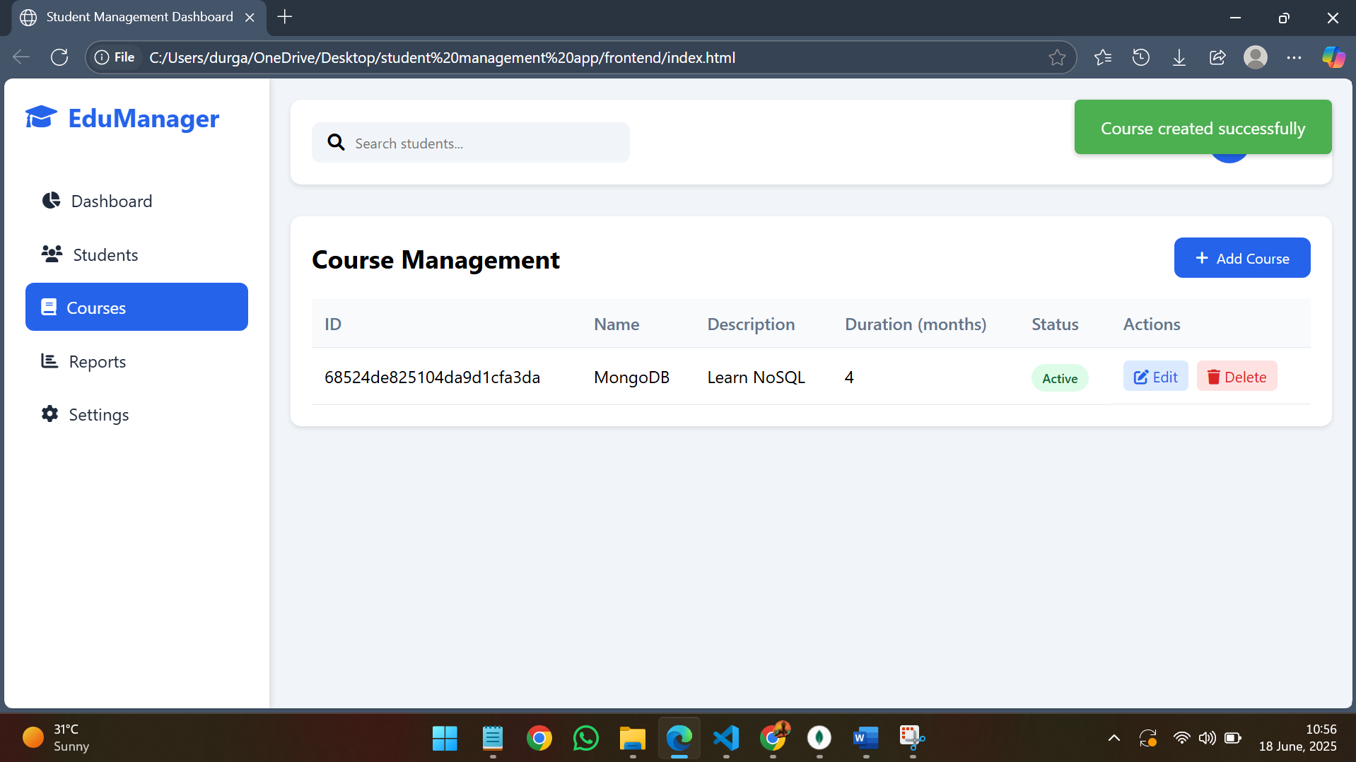

5.Initial view of compass.

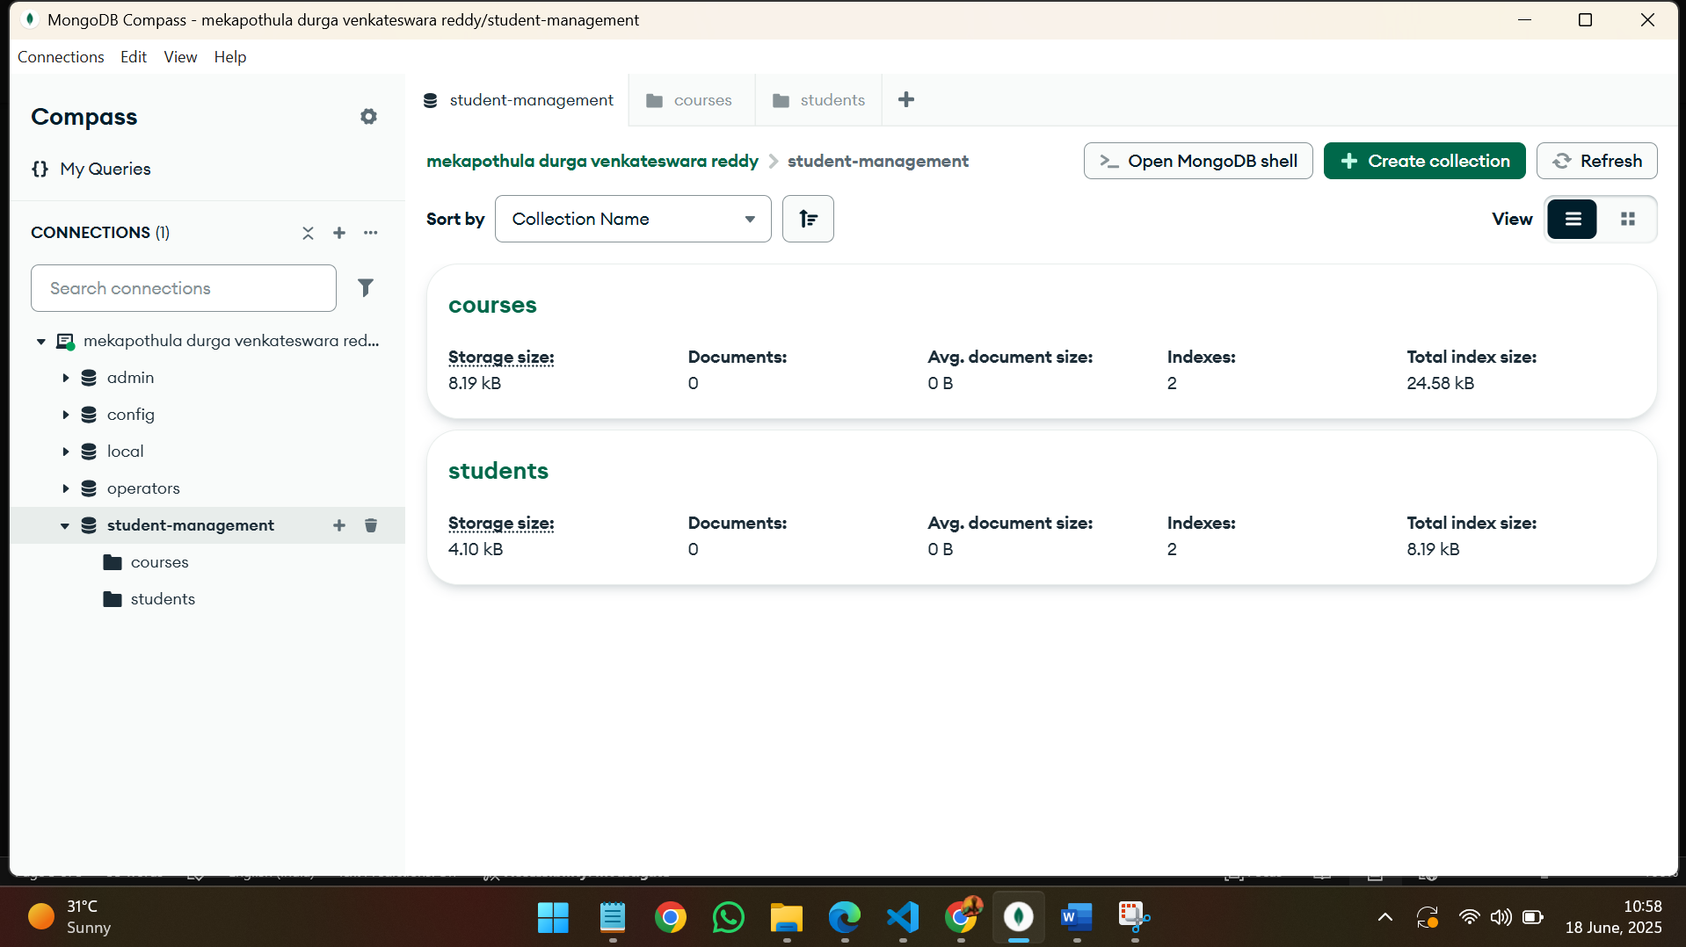

6.Empty course collection begore adding the course.

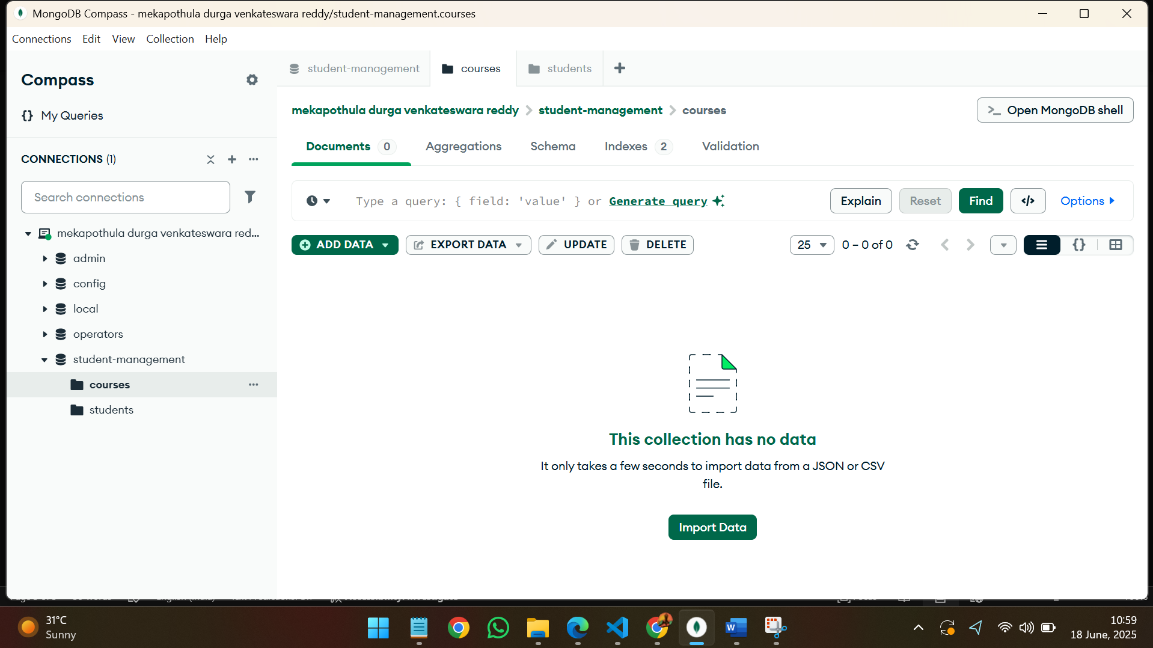

7.After refreshing we can see the course added in the web page in compass.

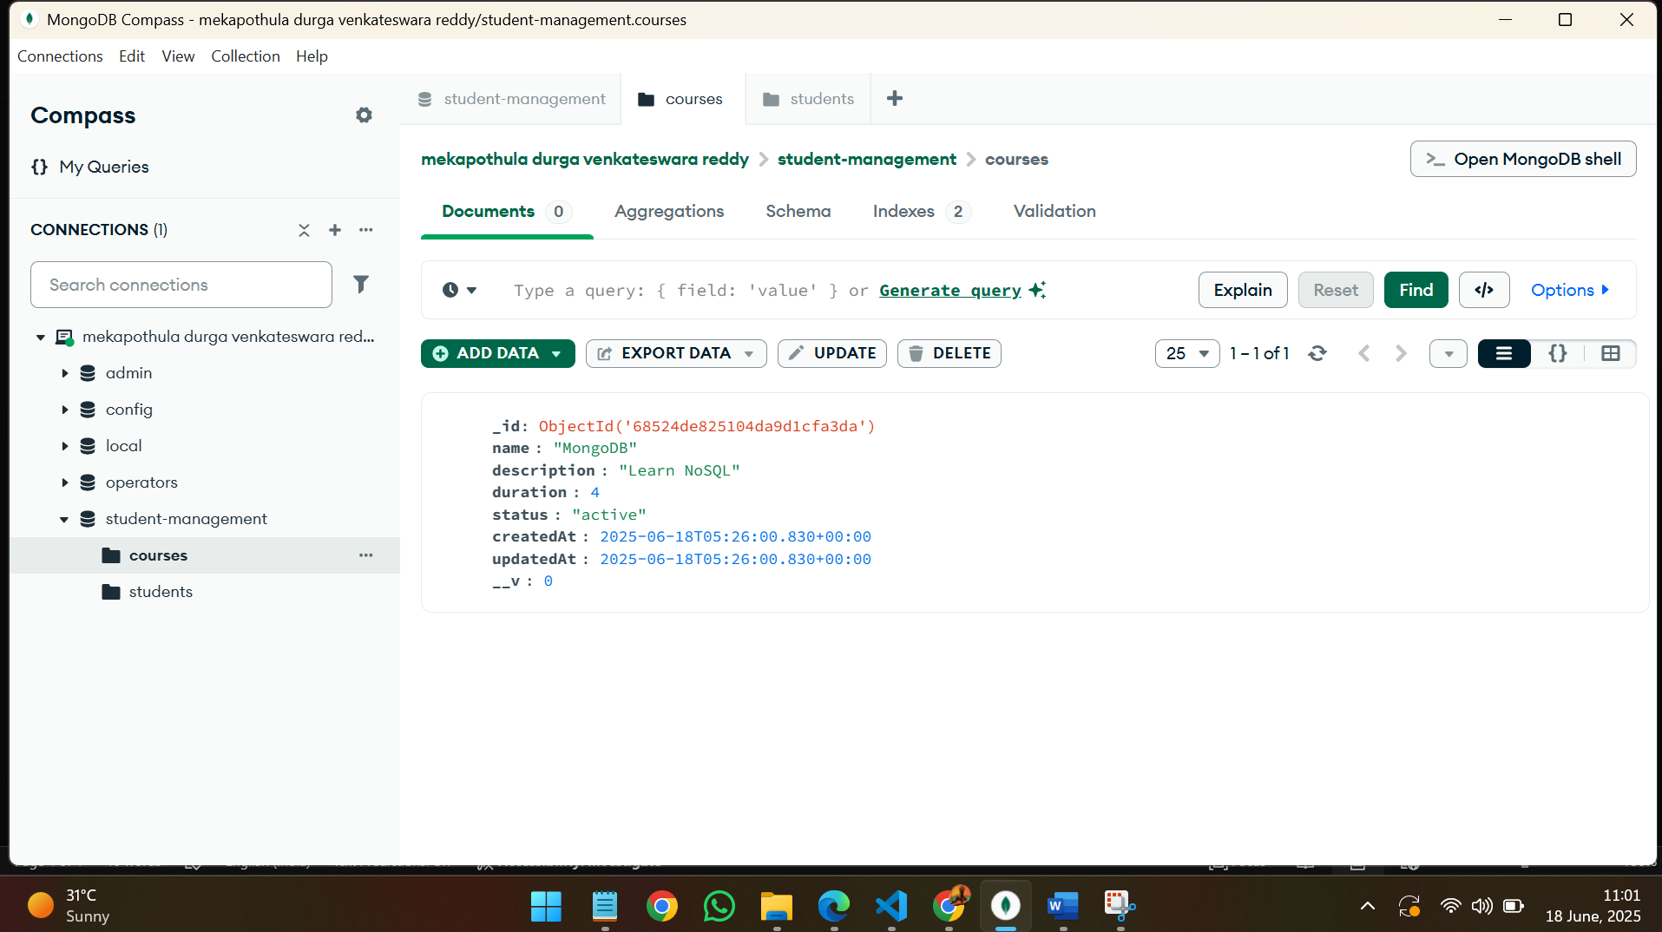

8.Editing the course details in web page.

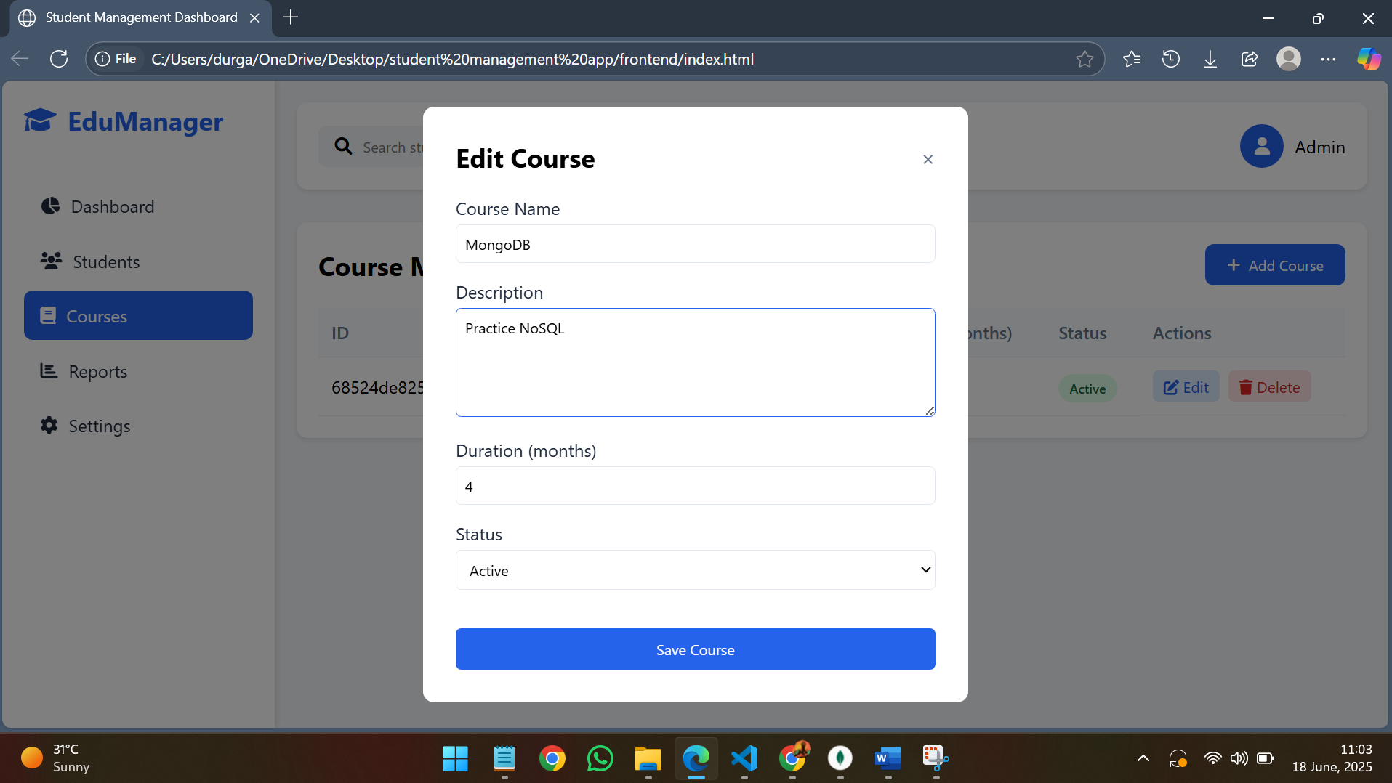

9.Successful update of course details notification in web page.

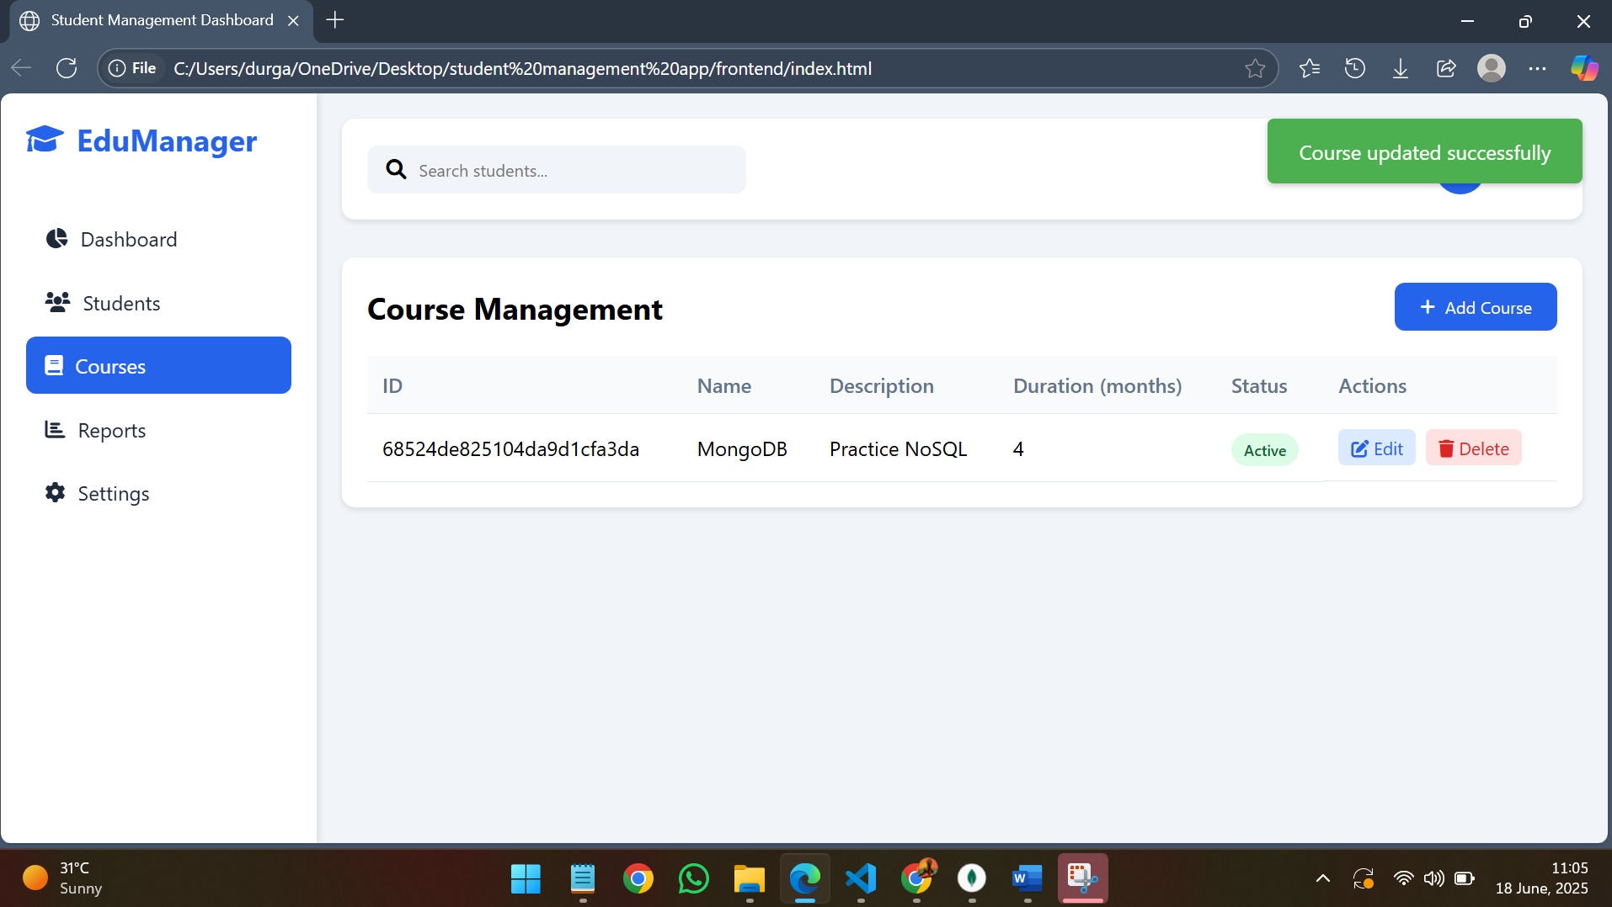

10.Trying to delete the course in web page.

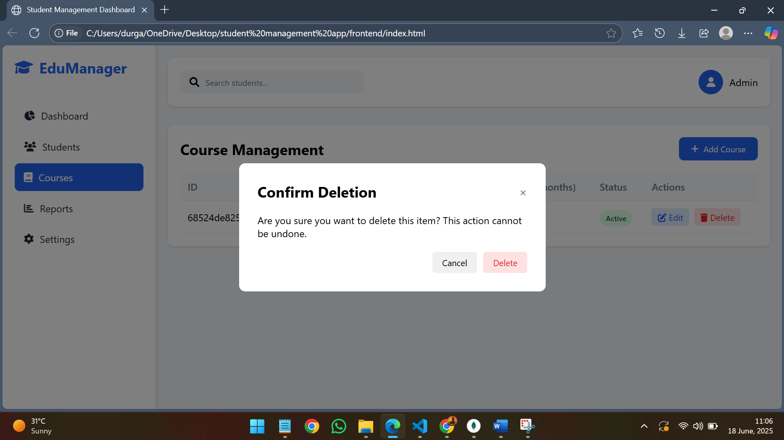

11.Notification of “course deleted successfully” in web page.

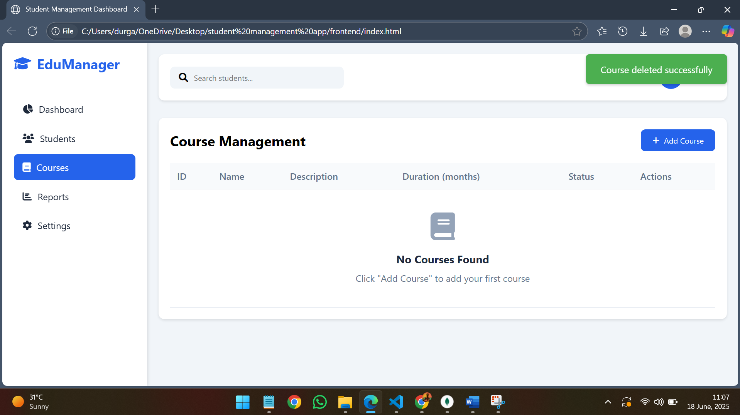

12.Now if compass is refreshed course is also deleted from the MongoDB.

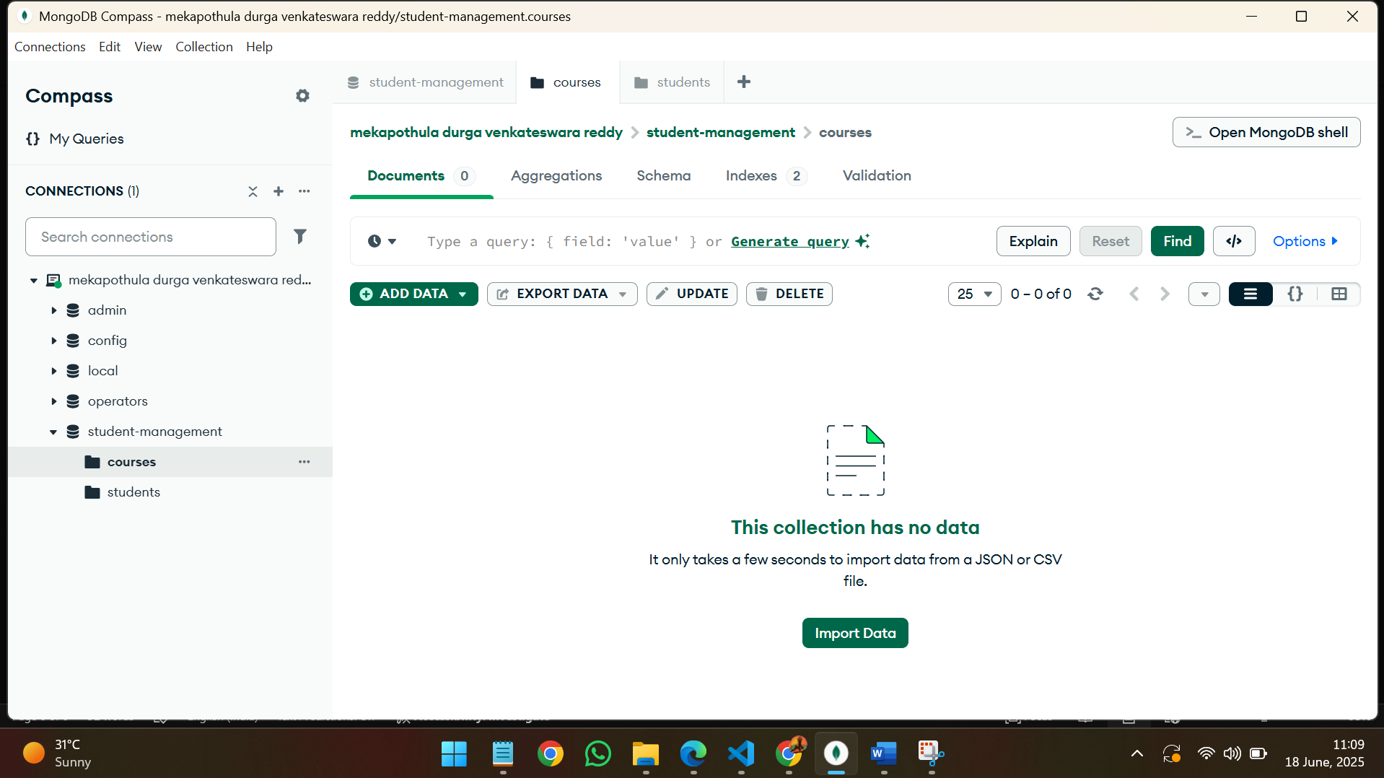

13.If any course is present now students can be added. Filling the student details.

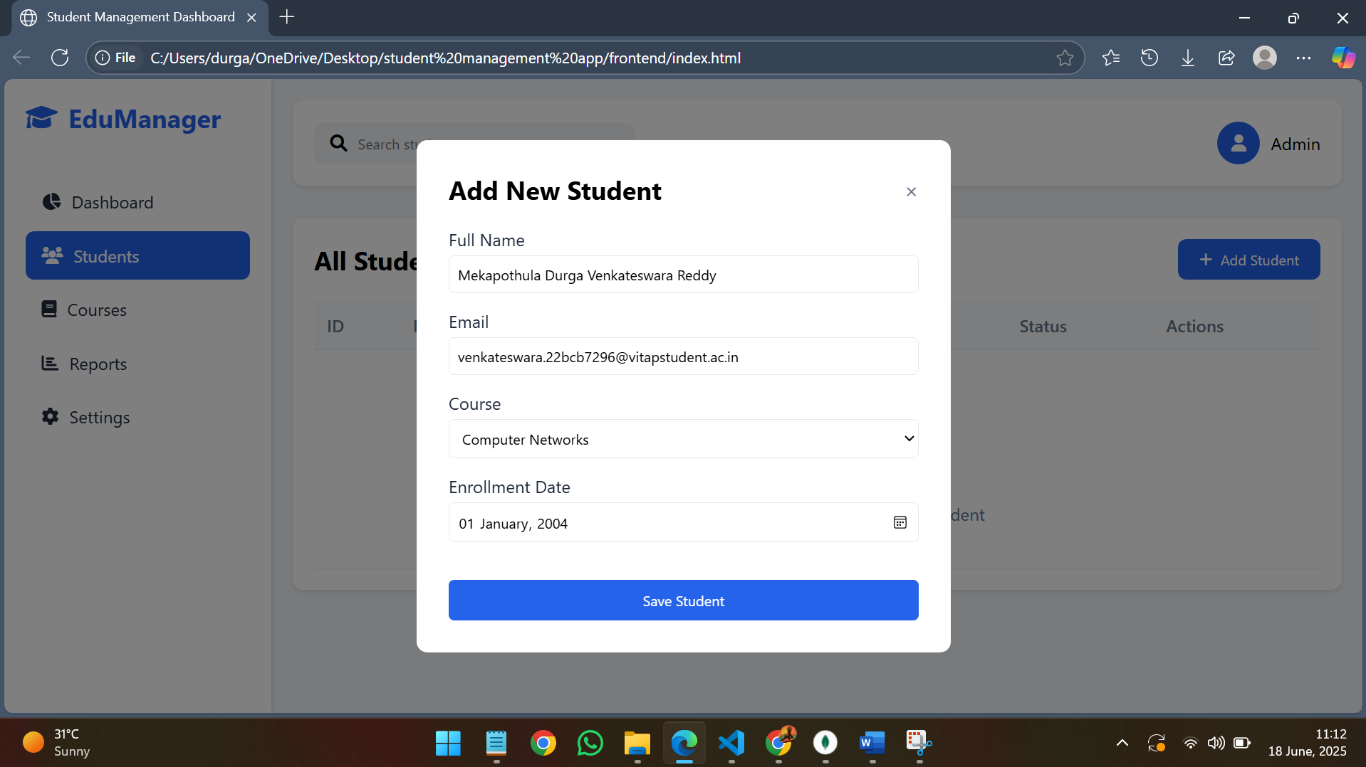

14.” student created successfully” notification from the web page.

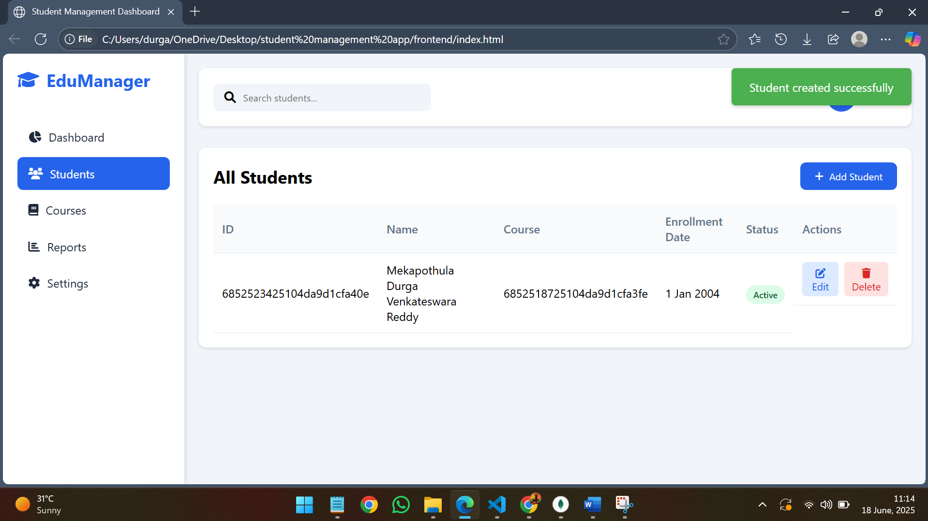

15.Now we can see the added student details in the compass.

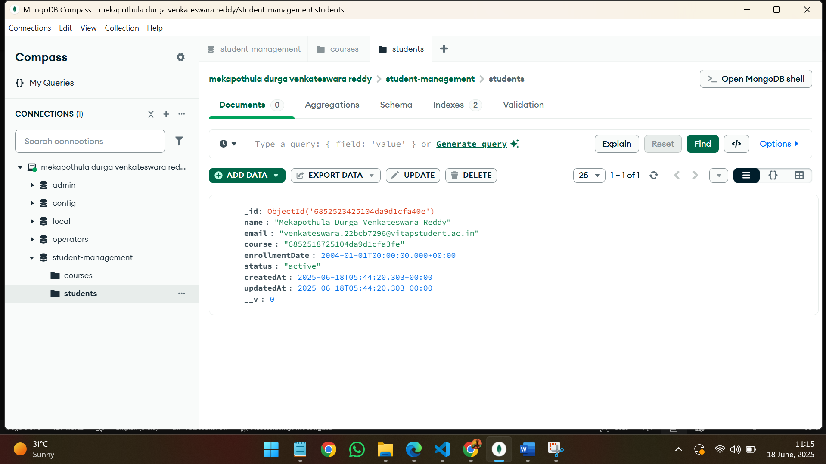

16.Editing the student details in the web page.(course is edited in student record)

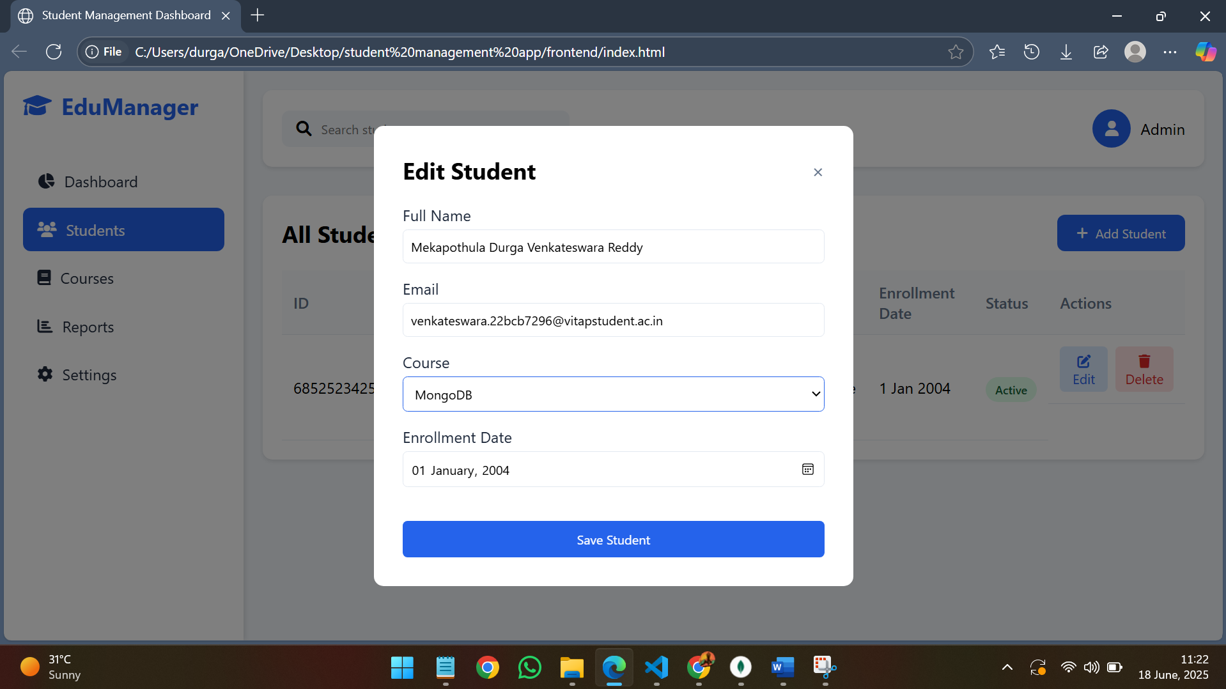

17.” student updated successfully” notification in the web page.

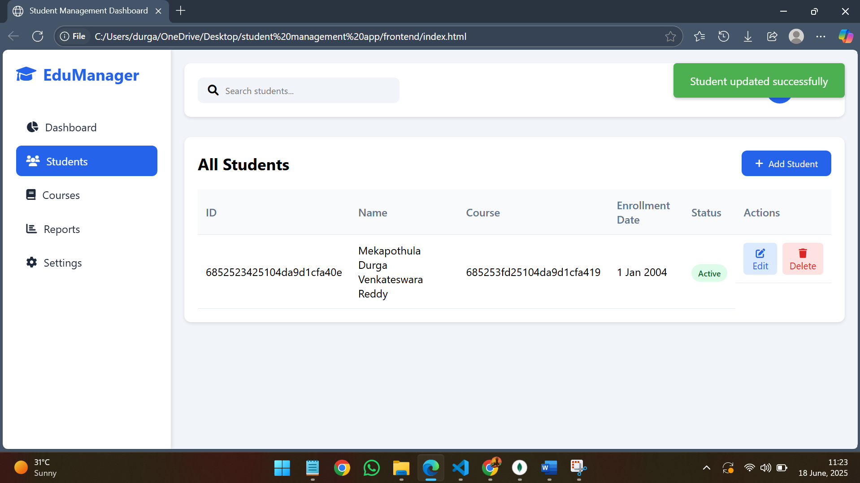

18.We can see the updated course id in the compass after updating the course in the student record as shown above.

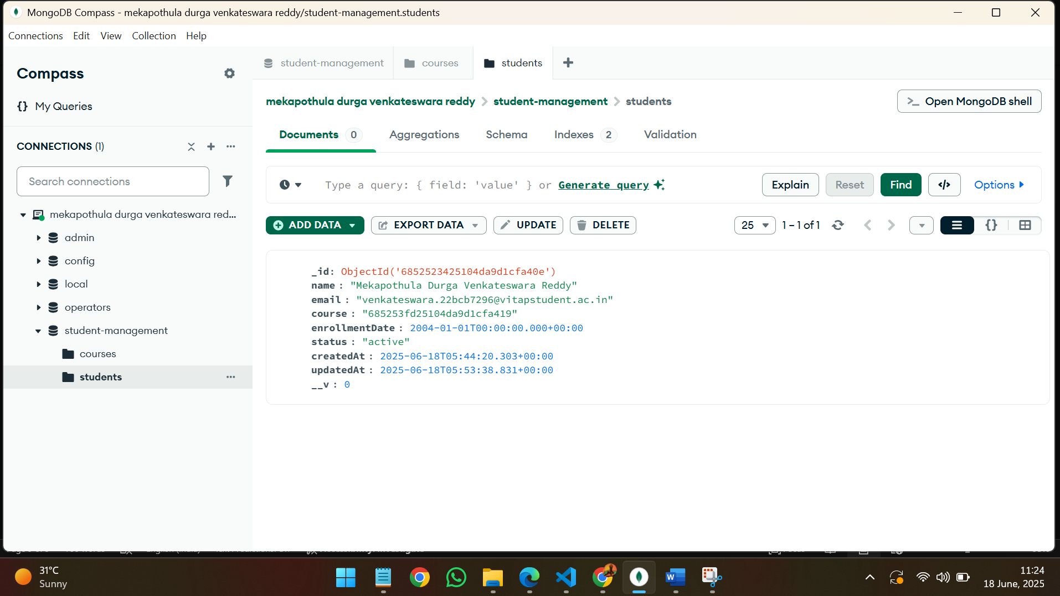

19.Trying to delete the student record from the web page.

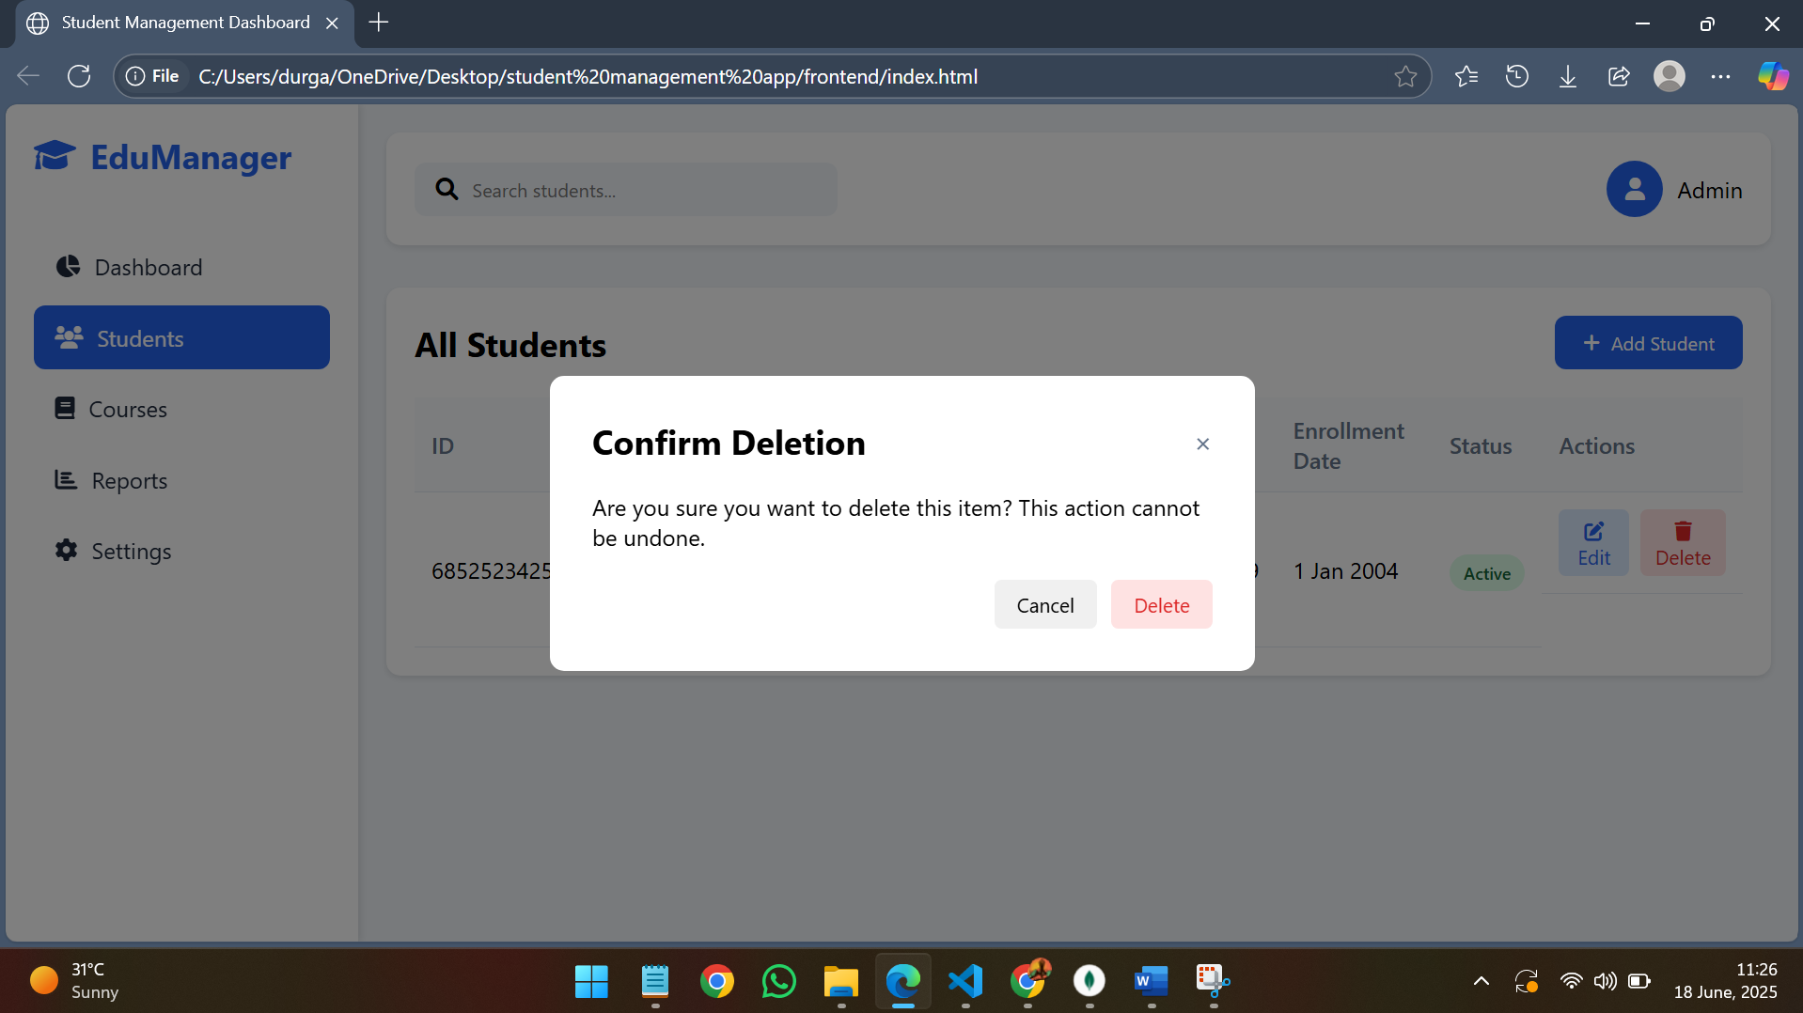

20.” student deleted successfully” notification in the web page.

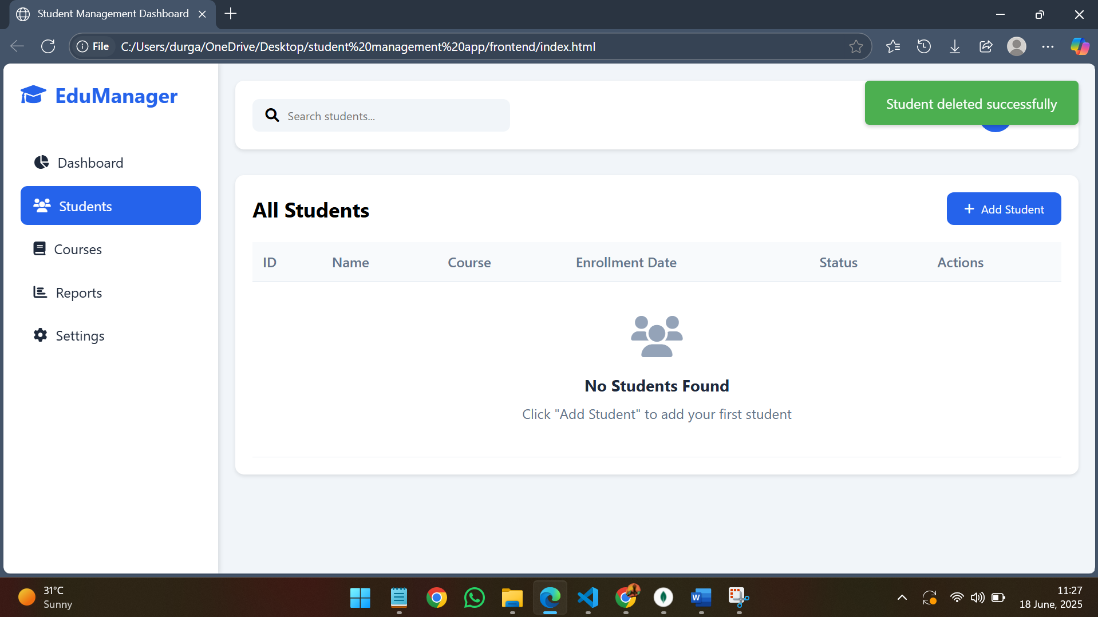

21.student collection is empty int the compass, after deleting the student record in the web page.

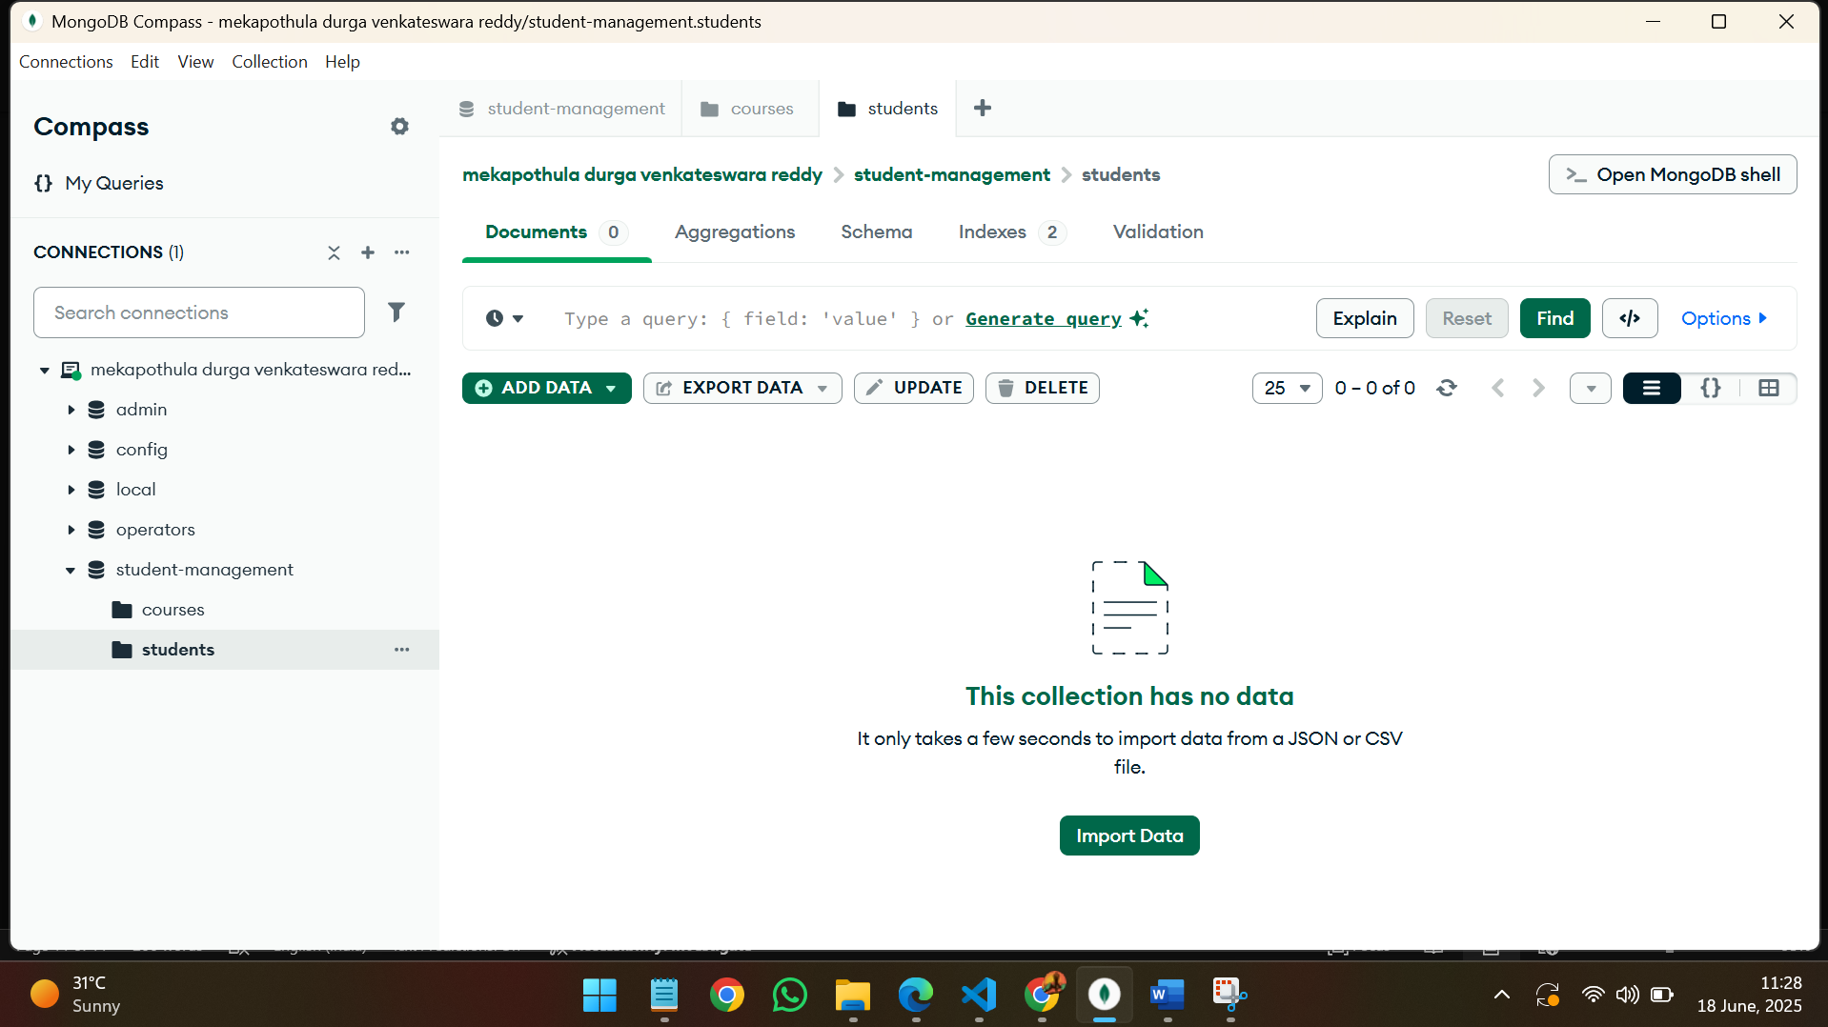

22.Searching a particular student with name.

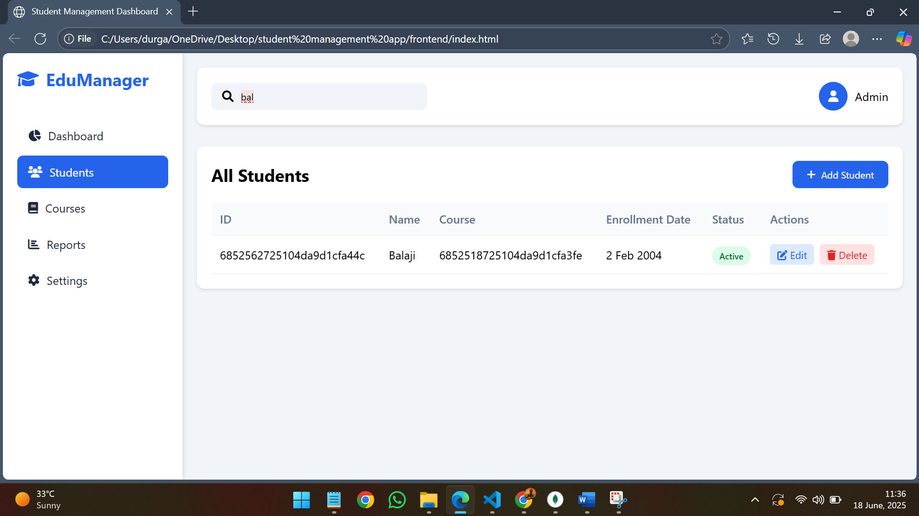

23.In the dashboard we can see the total number of students and active courses.

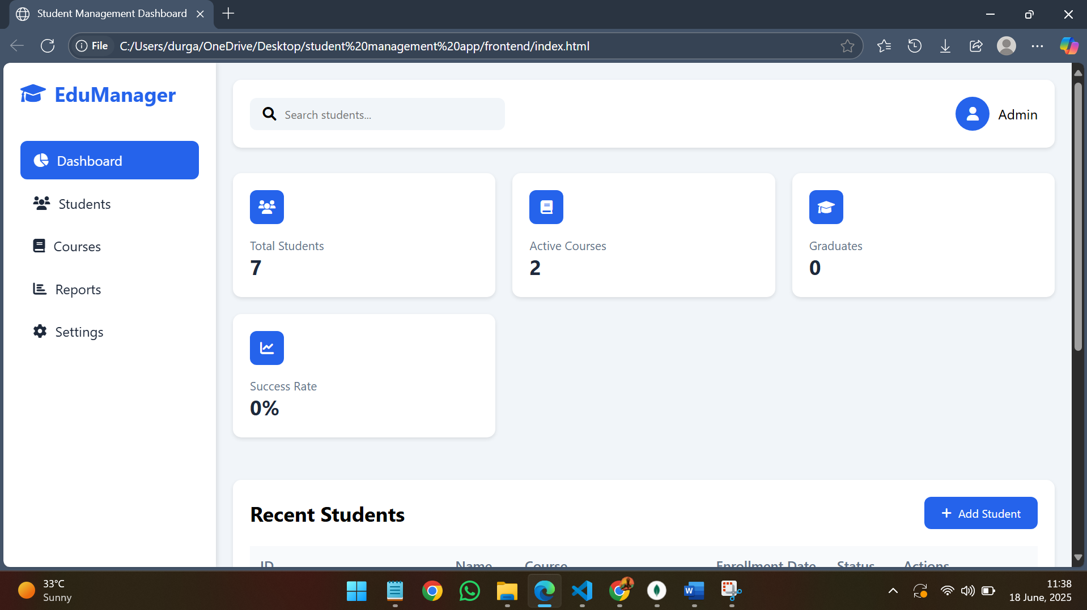

24.Editing the student record in compass.

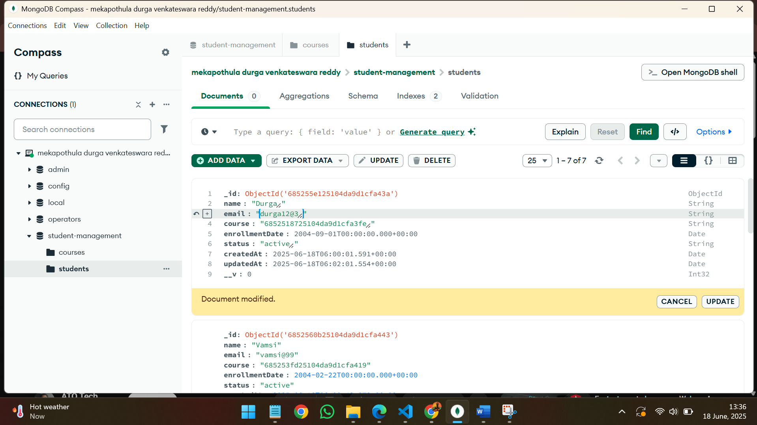

25.Trying to delete the student records in compass.

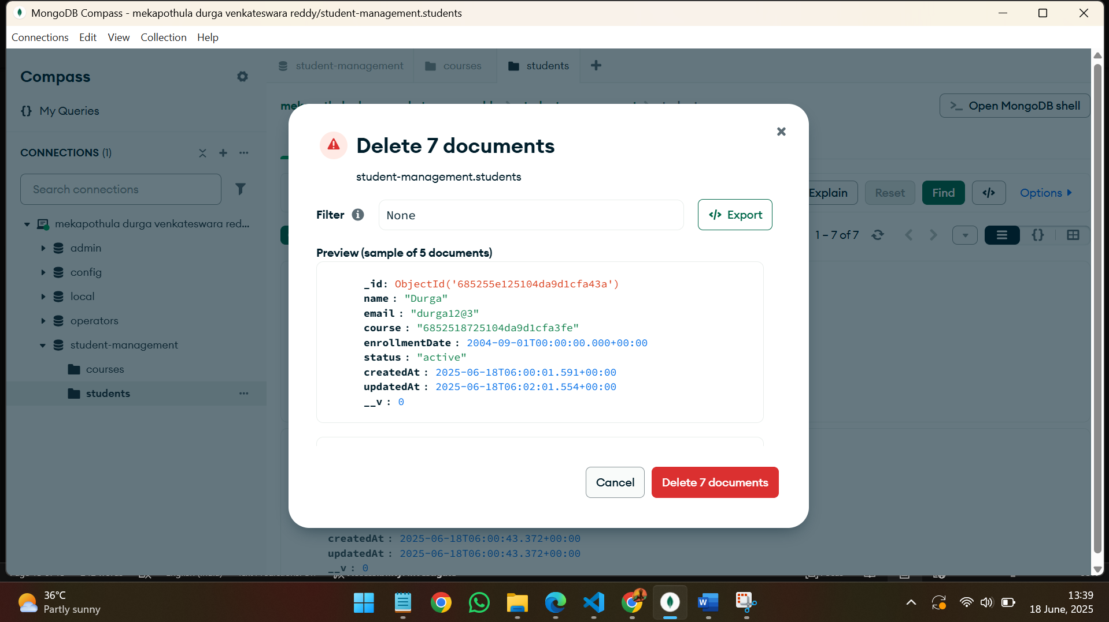

26.Updating all documents in students collection in compass.

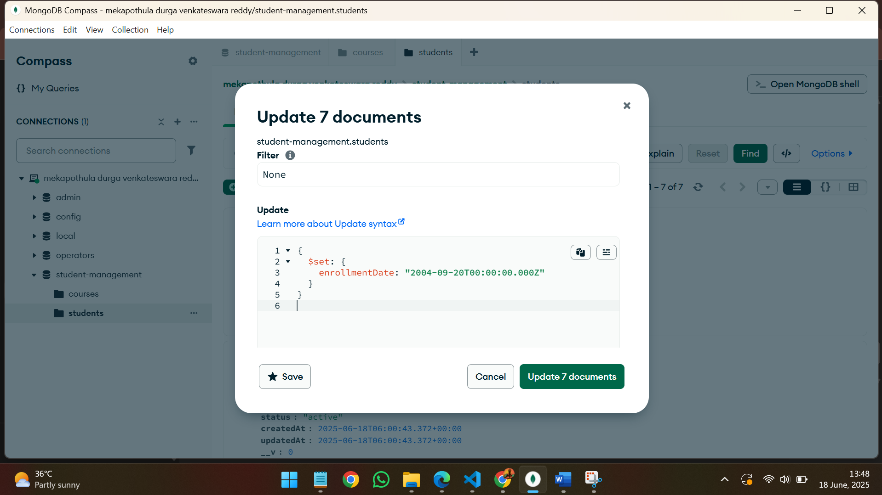

27.The update in the compass is reflected in the web page, changing all enrolment dates to 20 sept 2004.

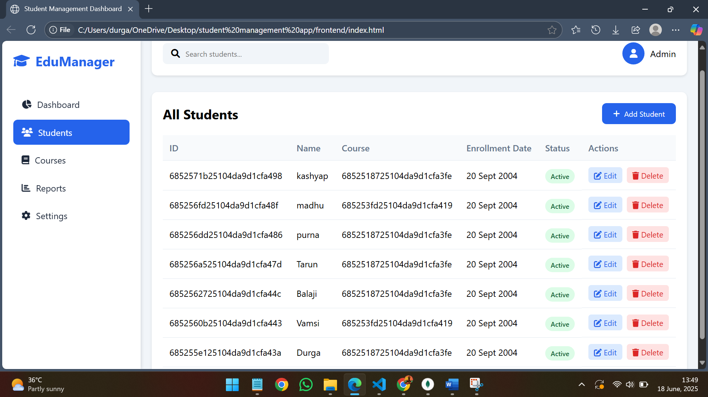

28.Inserting new documents in students’ collection in compass.

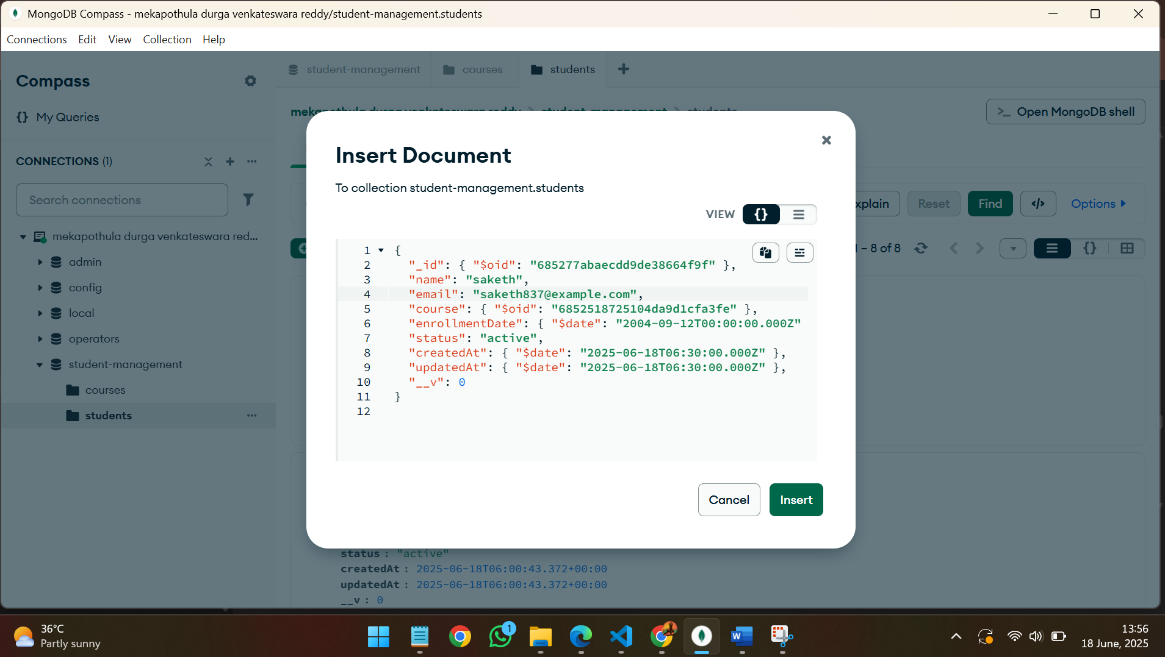

29.Newly inserted documents are now visible in the web page.

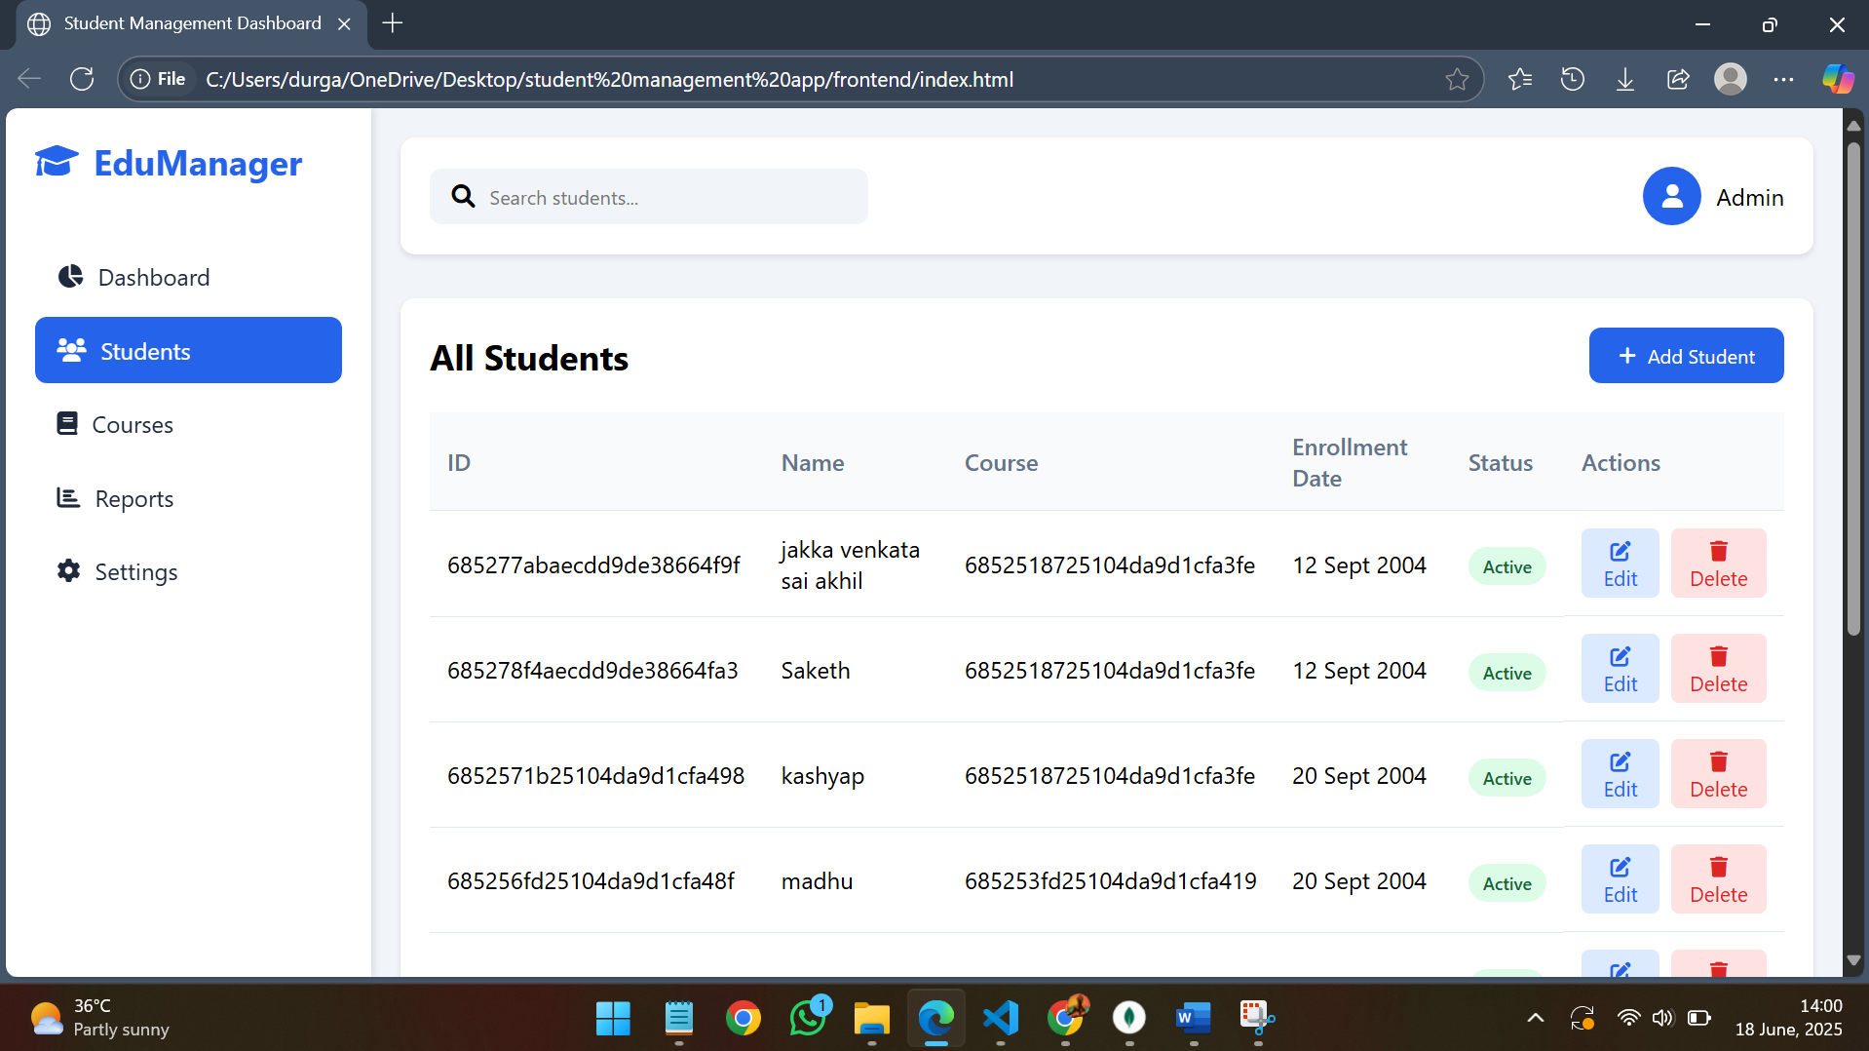

30.Finding the specific documents from the student collection.

Like email id containing letter ‘d’.

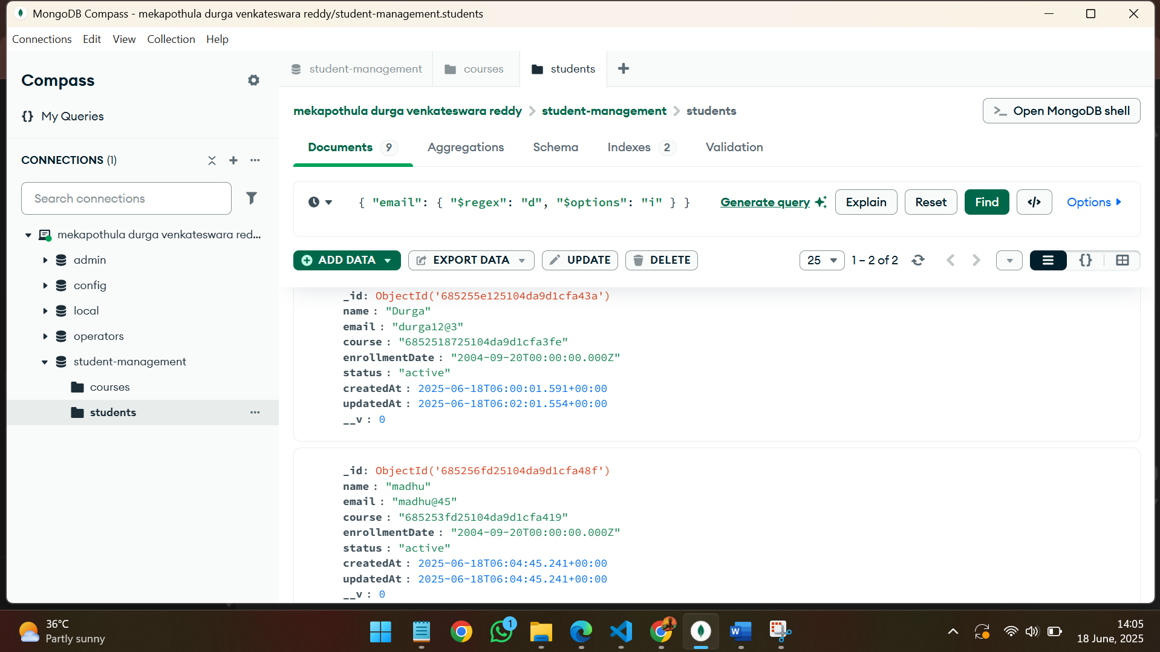

31.node.js connection.

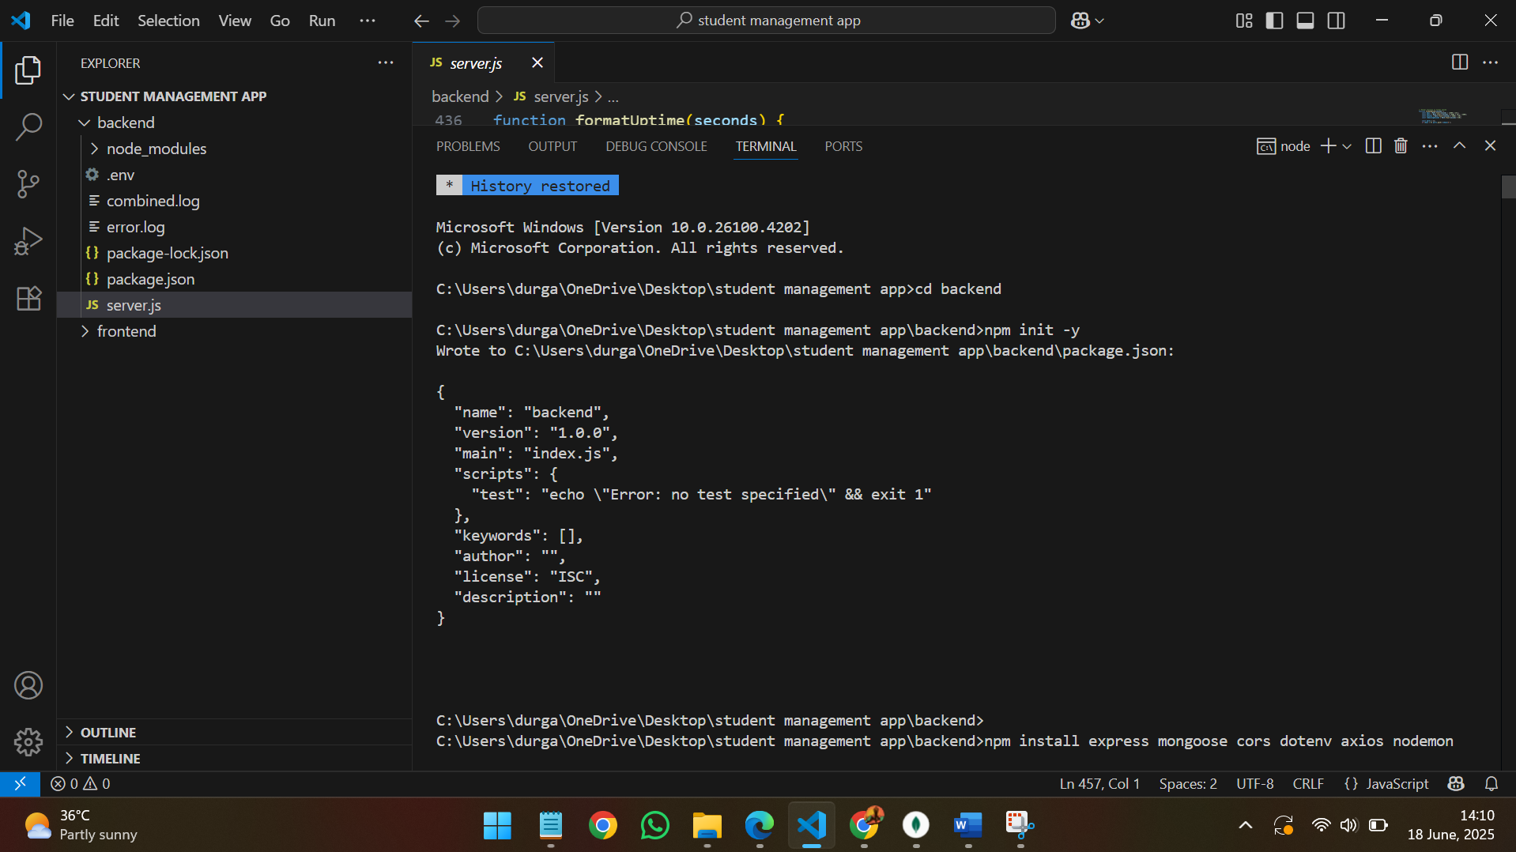

32.Packages installed.

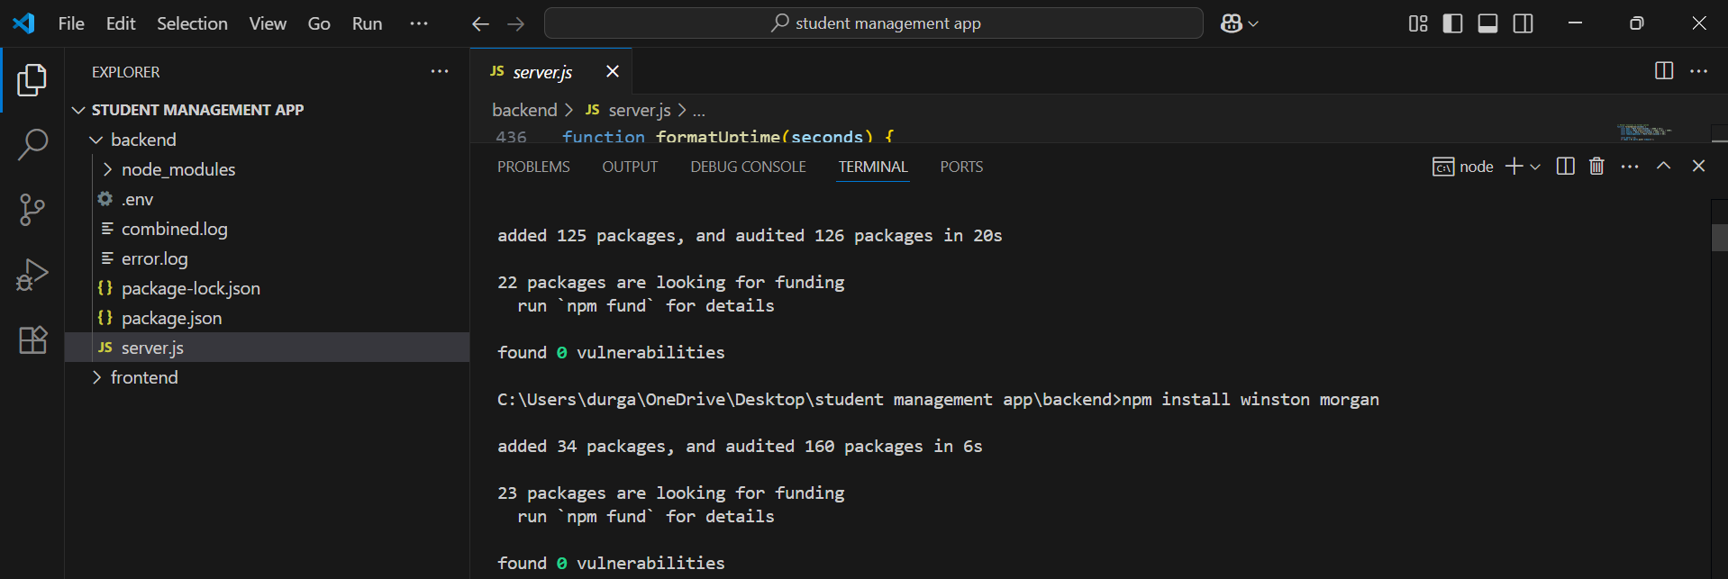

33.node.js server connection on port number 3000

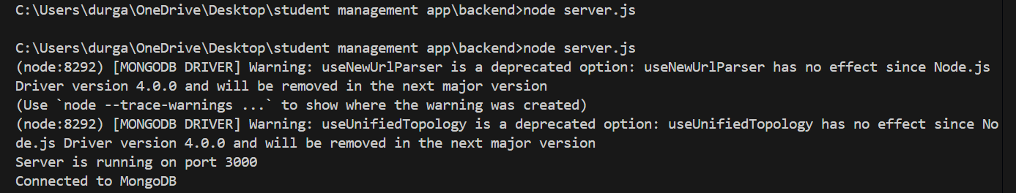

34.API calls

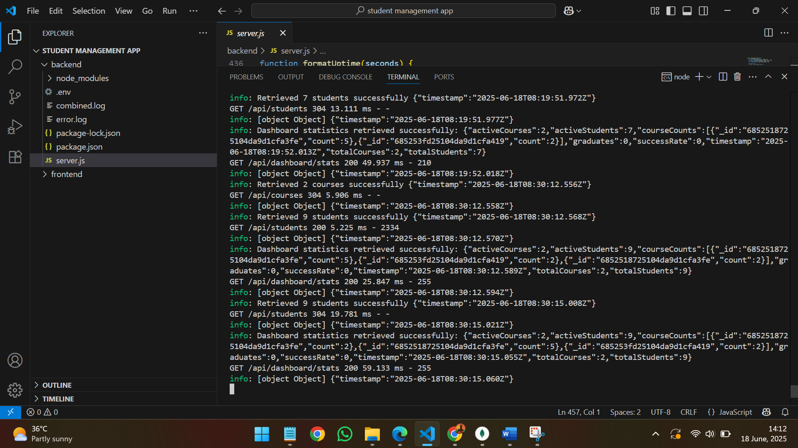

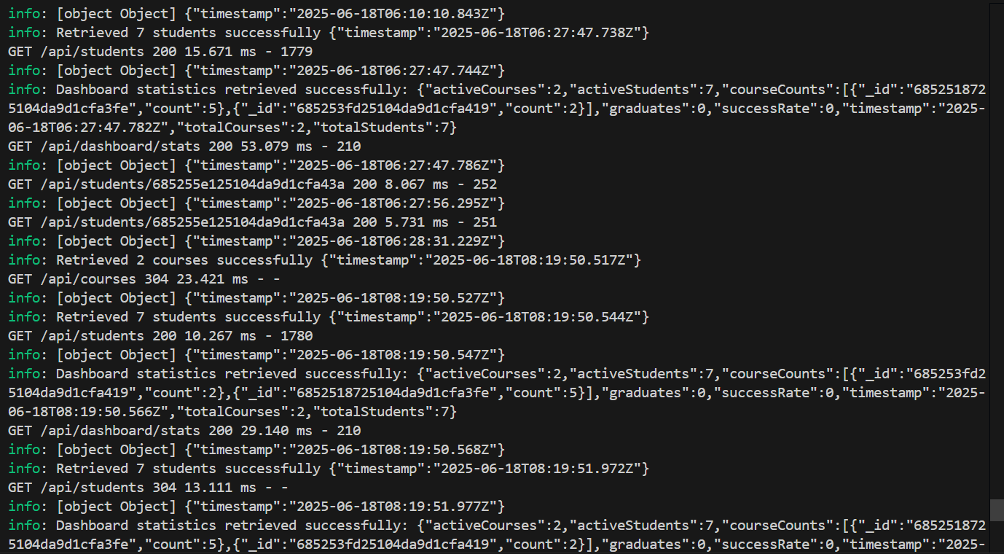

35. end point “health”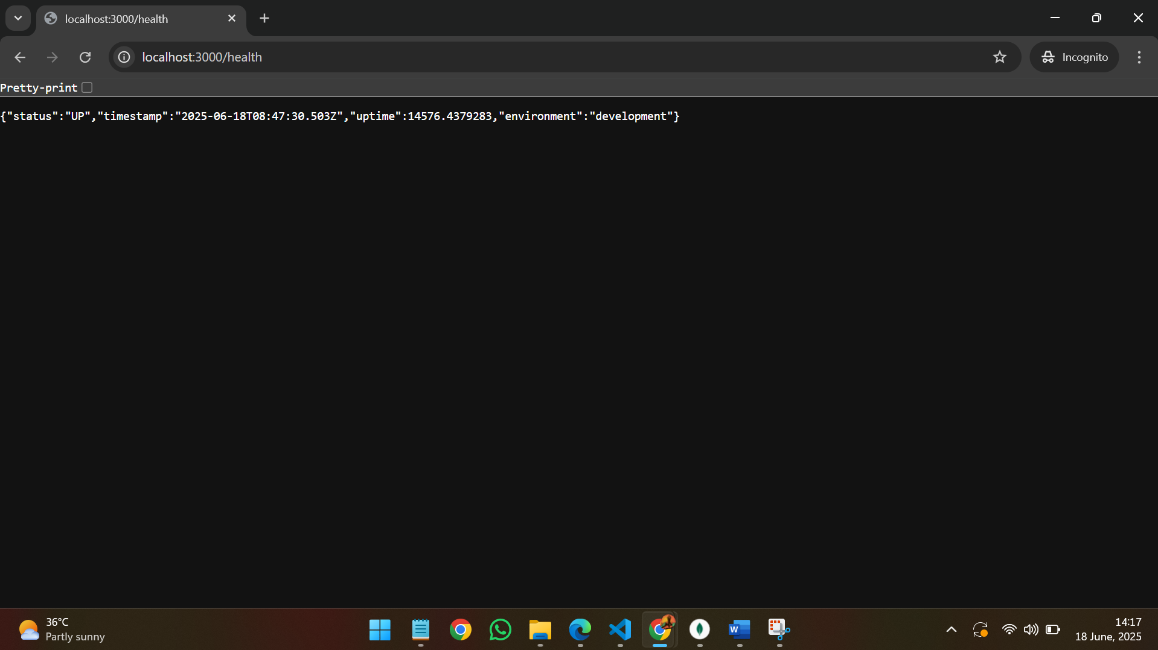

36.end point named “health detailed”

